# Communities in the Clouds: Final Report

Contents

Communities in the Clouds: Final Report 1

1 Acknowledgements 1

2 Project Summary 1

3 Summary of Project outputs 2

4 Workplan retrospective. 4

4.1.1 Phase One: Fieldwork 4

4.1.2 Phase two: prototype deployment 8

4.2 Outputs 10

4.2.1 Key outcomes from resident-focused fieldwork 10

4.2.2 Key outcomes from management-focused fieldwork 13

4.3 Impact 13

4.3.1 MSR Workshop 14

4.3.2 Erith Park photo booth deployment 14

5 Conclusion & Implications for the future 15

# Acknowledgements

First of all, we’d like to extend many thanks to IT as a Utility+ for funding this pilot project and for their support throughout. Thanks also go to Alex Taylor at Microsoft Research who has been generous with both his time and ideas and helped steer the project to a successful conclusion. Thanks also go to members of the Barbican and Golden Lane Community who agreed to be interviewed, attend meetings and provide responses to our many questions. Thanks also to Andrew Denny at Burrells Wharf who was generous with his time and his effort liaising between us and the Burrells Wharf management team. Thank you also to Sarah Fox for all of her hard work. Her tireless work visiting, interviewing, documenting and analysing has played a crucial part in the success of this project. Finally thanks to Caroline Field and Francois Jensen and all of the Erith Park residents that engaged with and continue to use our prototype at Erith Park.

# Project Summary

The focus of this pilot study was to assess the role that technology might play in supporting issues peculiar to high-density and high-rise living.  This domain is both complex and unique: obstacles emerge from a sophisticated physical infrastructure (utilities, rules and regulations, shared resources), multiple stakeholders (tenants, management companies, contractors, landlords, on-site staff etc.), legislative complexity (e.g. UK's leasehold laws) and the challenging relationships resulting from residents’ shared financial and emotional stakes in their buildings.

The project set out two strands of work:

1. An investigation into residential communities and their use of technology. This included on-site interviews with residents, the analysis of online residential forums, meetings and workshops with residents and stakeholders and onsite field work. The deliverables that relate to this work are D1.2 and D1.1 and can be found online and attached with this report.

2. ‘Real world’ deployment of prototype probe(s), drawing on the outputs that emerged from the empirical work. We are running a deployment in Erith Park, Orbit Housing’s flagship residential estate in South East London in collaboration with Orbit Housing, which we are hopeful to extend assuming we are able to generate further funding.

This document summarises the work undertaken, the lessons learned, the outputs and follow on work.

# Summary of Project outputs

The following table is a list of all of the documents (deliverables, blogs and transcripts) and code generated in this project. Transcripts of interviews with residents, and the documentation of the two day shadowing of a concierge in an East London estate can be made available on request.

|  |  |
| --- | --- |
| **Output / Outcome Type** | **Brief Description and URLs** |
| Project Website and Blog | Main project website with blog and documents repository. <http://www.upintheclouds.org> |
| D1.1 Workshop | D1.1Managment report  <http://upintheclouds.org/assets/doc/D1_1_Scoping_Study_Management.docx>  A full transcript can be found at:  <https://communitiesintheclouds.files.wordpress.com/2014/08/17jul-workshop-transcript.pdf>  Slides presented on the day:  <http://upintheclouds.org/assets/doc/D1_1_workshop_one.pptx> |
| D 1.2/2.1 Scoping Study | Scoping study:  <http://upintheclouds.org/assets/doc/D1_2_Scoping_Study_Residents.docx>  2 day shadowing of concierge in Burrells Wharf**:**  **a full report/transcript from these two days can be made available upon request (we have not published it due to the sensitive nature of the material) .**  Sarah Fox blog  <https://communitiesintheclouds.wordpress.com/>  Barbican forum discussions based on comic strips:  Forum discussions on rules & governance:  Rules:  <http://www.barbicantalk.com/forum/viewtopic.php?f=2&t=12404>  Governance:  <http://www.barbicantalk.com/forum/viewtopic.php?f=2&t=12378> |
| D 2.3: Code Release | Forum analysis code  <https://github.com/tlodge/spiders>  visualisation code:  <https://github.com/tlodge/cloudcommunities.website>  The code for the Erith park photobooth app:  <https://github.com/tlodge/erith-react> |
| D 2.2/D2.4 Prototype Interfaces and Deployment | The project created a set of software prototypes to explore how data might be visualised in a residential community. To see it in action, go to: <http://upintheclouds.org/tools/building/>  Barbican forum analysis visualisation:  <http://upintheclouds.org/viz/barbican/>  Erith Park deployment:  <http://upintheclouds.org/assets/doc/D2_4_Erith_Probe.docx> |
| Poster/Workshop Paper | UBICOMP workshop position paper for community in the clouds:  <http://www.ubicomp.org/ubicomp2013/adjunct/adjunct/p829.pdf>  Poster  <http://upintheclouds.org/assets/doc/cc_poster.pptx> |
| D3.1 Follow on proposals | Communities & Culture:  <http://upintheclouds.org/assets/doc/D_3_1_communitiesandculture.pdf>  Horizon:  <http://upintheclouds.org/assets/doc/D_3_1_community_screens_in_the_wild.docx> |

Table : Summary and location of outputs

# Workplan retrospective.

### Phase One: Fieldwork

The aim of the first strand of our work was to familiarise ourselves with large scale residential environments: the communities that inhabit them, the experiences of living in them and the processes at play in managing them. We were fortunate to have links with three large residential communities in East London but were keen to cast the net more widely to obtain as wide a range of residential developments as possible. A significant portion of our study of residents and their communities was on the Barbican in central London. The Barbican is a large complex, split across 3 high-rise residential towers and 18 low-rise blocks flats. It was chosen because it has a large community (around 4000 people living in approximately 2000 apartments), it is well established (opened in 1969), it has enjoyed a relatively recent resurgence in popularity, resulting in a mix of early local authority tenants and private housing: urban professionals and families with children. It also has a long-running and vibrant online forum. We were also able to gain access to residents in a neighbouring development: Golden Lane. Golden Lane is a 1950s council housing complex, comprising mainly of studio and one bedroom flats. It houses approximately 1500 people, with many flats now privately owned. There is a larger proportion of council and housing association tenants than in the Barbican. In addition to these two communities we had access to ten online residential forums. We build a simple categorisation tool to classify and rank posts for sentiment, for which we have made the code available (see the ‘code release’ section of the summary of outputs table) . Figure 1 shows the top level categories (and some example subcategories). Figure x shows the positive and negative sentiment analysis scales.

Figure : Top level categories of forum content

Figure Sentiment scale

Our management fieldwork concentrated on Burrells Wharf, in East London, given a pre-existing relationship with the management team there. Burrells Wharf is a riverside residential community. It is on a site consisting of eleven separate buildings, three of which are Grade II listed. It is built upon the shipyard site where the Great Eastern steamship was launched in 1850. It has an onsite gym, pool and concierge. The development consists of privately owned housing, with a mix of owners and tenants.

Our approach was to study the communities from a variety of perspectives;

1. to study online forums (a rich source of longitudinal data of the concerns and interests of residential communities);
2. to interview residents and management staff
3. to undertake site visits
4. to run a workshop to bring together a variety of ‘stakeholders’ (management, staff, residents, businesses)
5. to engage users on forums (more specifically, on barbican’s forum: www.barbicantalk.com)

The outcomes from (i) are summarised in this report and discussed in D1.1. The outcomes from (ii), the interviews, are summarised in this report and presented more fully in D1.2. Descriptions of site visits to the Barbican and Golden Lane and a community event can be found here[1]. The report on a two day shadowing of the Concierge team at Burrells Wharf can be provided on request. Presentations, outcomes and transcripts from the workshop (iv) can be found in D1.1, and online[2] [3].

To accomplish (v.), i.e. engage with an online community, our approach was to work through the forum material, and then offer up a picture of the community back to itself. There were two parts to this; first we wanted to be able to offer an alternative view of the details of a forum back to the residents; we categorised a large amount of the (semi-structured) content, performed a sentiment analysis (using a two-part (positive/negative) scale[4]); this latter task was performed manually in order to ensure our analysis was consistent and able to deal with the subtleties language. The outcomes from this work were presented as a set of visualisations (**Figure 1**); the live version can be viewed here[5]

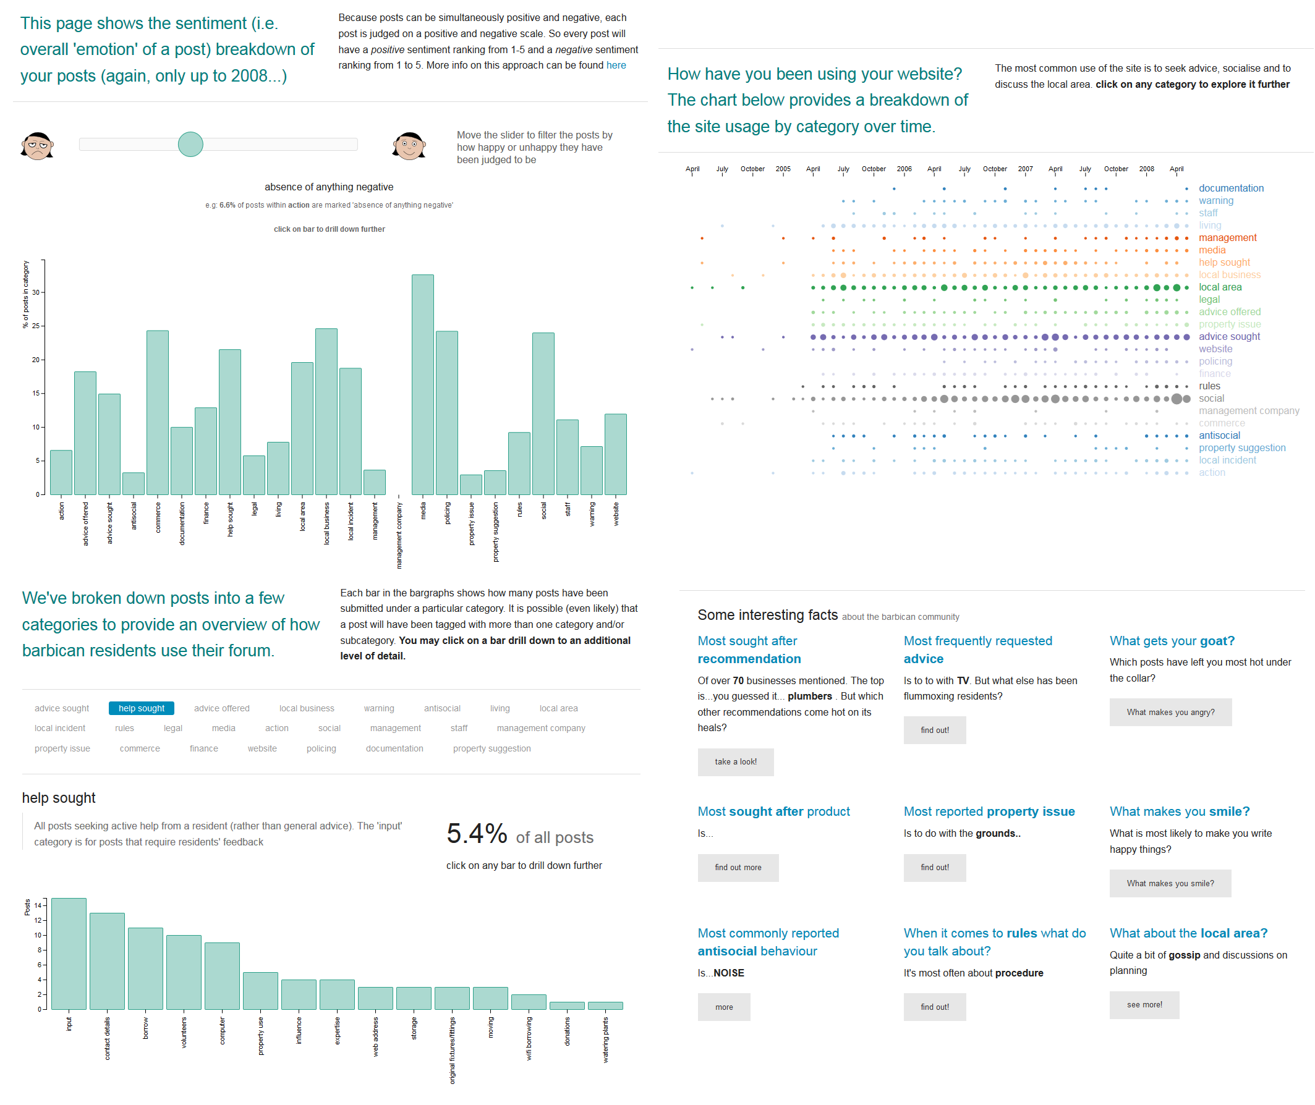

Figure : Barbican Visualisation, see http://upintheclouds.org/viz/barbican

To pique interest we picked out contentious / recurrent themes and turned them into comic strips. We posted these on the Barbican forum for comments, alongside quotes from the relevant forum threads and invited users view the data.

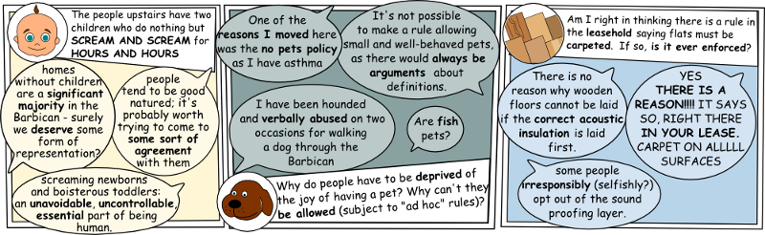

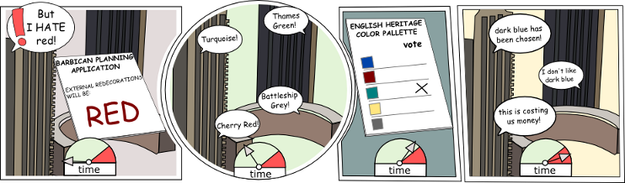

Figure : Barbican comic strips

As a means for generating further discussion, the comic strips were a useful vehicle. However, the posts were competing against many more, few residents clicked offsite to our visualisations and as the discussions (particularly around rules) progressed, and posts were met with some scepticism with regard to our motivations:

**RESIDENT A:** “what are you planning to do with your findings once you have stirred up a whole lot of discussion?”

**RESIDENT B:** “I share **[RESIDENT A’s]** feelings. Things work reasonably well at the Barbican. Problems are looked at and solved as they arise. Don't see the need to bring the lease & its interpretation into this.

**RESIDENT A**: What we don't want is a 'Snoopers App', which is where your line of questioning seems to be heading. If neighbours bother us we have the choice of paying them a friendly visit to discuss the problem or discussing it with the House Officer, both face to face. It's what makes the Barbican 'liveable'[..]I think that we should strongly resist any form of anonymous 'Report your Neighbour' app

**RESIDENT C:** Incidentally, much as I enjoyed the cartoon, it betrays a high level of familiarity with what goes on here. Do we know you by another pen name?

### Phase two: prototype deployment

The second strand of our work was to deploy a probe in a residential environment to consider how technology might better support these large residential communities. Our original intention was to work with Burrells wharf, and use the outcomes from our fieldwork to provide a ‘solution’, such that there would be incentive from management and residents to use it. One outcome from our fieldwork was the theme of civic engagement and governance; how to provide communities with more effective channels for achieving consensus and accomplishing collective goals. During the onsite fieldwork at Burrells Wharf, one issue that emerged strongly was to do with parking; in particular spaces being used by unauthorised vehicles. In our workshop, one technology presented was postervote[6]: a low cost voting system, developed by Newcastle University’s Open Lab[7], this was met favourably by Managing agents and the Burrells Wharf Concierge. We designed and developed a postervote to give residents a vote on the installation of bollards to help solve the issue (see ). Although received enthusiastically by the concierge, the installation of the prototype needed to be sanctioned by the resident’s board of directors. Unfortunately we were unable to get the final permission for this deployment, and so could not proceed any further.

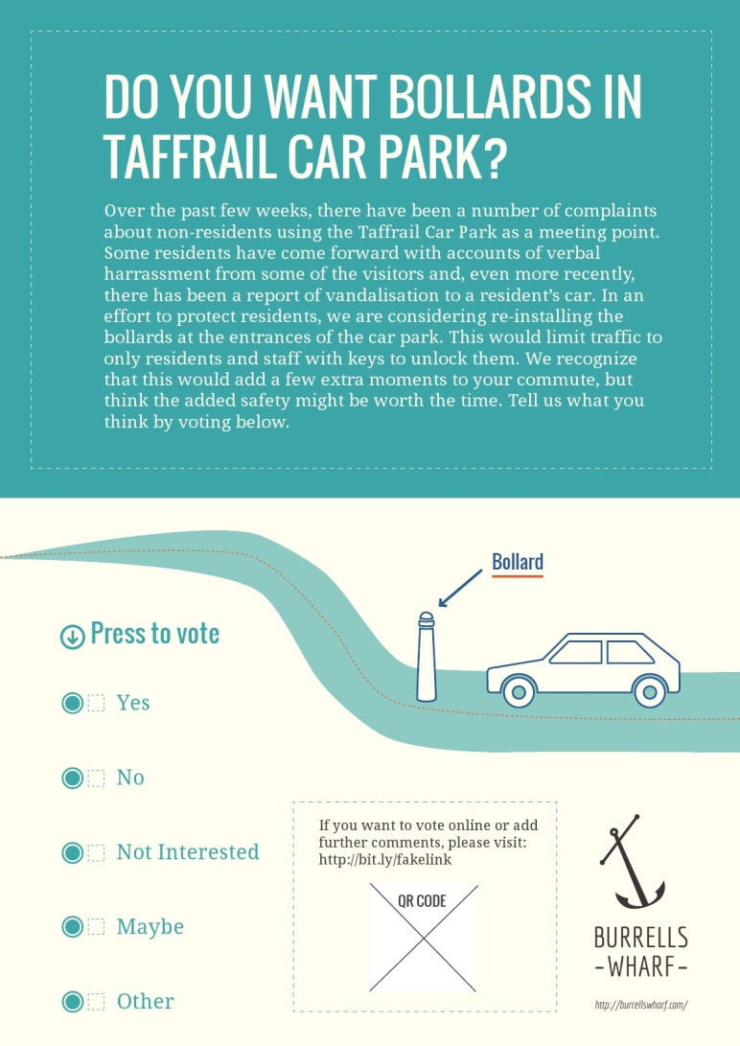

Figure : Postervote design

Another strong theme that emerged from our work was how community is thought about and enacted in these environments (see D1.2: *Defining a residential community*). D1.2 provides an illustration of the wide range of communities that might co-exist in a residential development. Our work suggests not only that residents undertake a variety of practices to determine the ‘health’ of their community, but that the informal approaches that they use differ significantly, alongside the resulting mental picture of the community that they inhabit. We considered a multitude of interfaces that might (i) encourage interaction between neighbours (ii) promote community building.



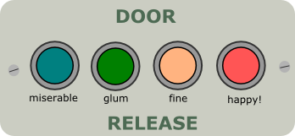

Figure Neighbourliness Interfaces

## This work dovetailed with discussions we’d had with Orbit housing (Orbit). Orbit look after 37,000 affordable homes, and see “building communities” as their role. Orbit is in the process regenerating an unpopular estate that suffered from crime and antisocial behaviour: Larner Road. The regeneration involves demolition of old tower blocks and the creation of a new development: Erith Park[8]. We were provided with an opportunity to consider how we might use technology to encouragement and sustain the incumbent community. Orbit ‘s ambition is to not only prevent Erith from following the path of its predecessor, but to create a place that people aspire to live in, where residents feel invested in community management. Our discussions focused on the (re)development of housing; residents share space, but not necessarily a sense of cohesion or tools to create this. Varied drivers exist, such as challenges with moving in, living harmoniously, resources such as parks or streets, shared interests such as childcare, and desires for meaningful local place-making. Our starting point was to develop interactive, situated screens in order to make place-related activities highly visible. A secondary advantage of this approach was that it had the potential to promote digital inclusion: a focus of current government initiatives.

We ran a second workshop at Erith Park, which was attended by Orbit/Erith park staff: (their Community Officer and Regeneration Manager), three early Erith Park (former Larner Road) residents and researchers from Microsoft Research, Newcastle’s Open Lab, UCLs Interaction Centre, Goldsmiths and Nottingham’s Mixed reality Lab. This and subsequent discussions resulted in the development of the Erith Park photo booth app. Figure 5 shows some early paper prototypes:

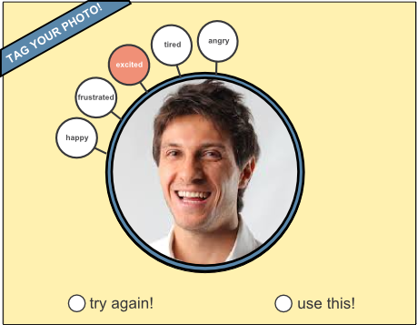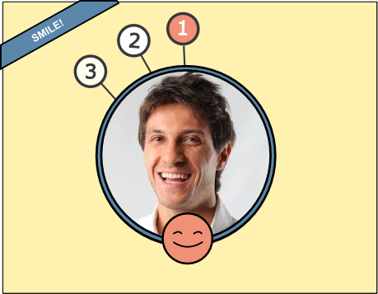

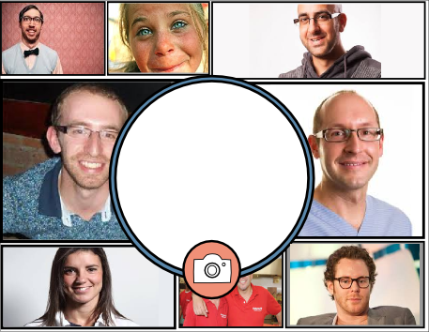

Figure : Photobooth prototypes

[reference to Erith park photobooth app]

## Outputs

### Key outcomes from resident-focused fieldwork

This section briefly summarises the most significant outcomes from oru resident-focused fiueldwork. For more information please refer to D1.2.

#### Impacts on community & community building:

1. **Residents attach importance to ad-hoc encounters as a way of building relationships** they are aware of distinct differences in the opportunities for engagement and interaction arising from the qualities of communal space. **The architecture of large residential developments is seen to play a fundamental role in a community’s relationship with the world directly outside it.** ‘Inward looking’ buildings and gated communities are often believed to insulate a community from (positive and negative) external influences. In addition, in larger estates, such as the Barbican, the architecture is believed to play a role in generating separate communities, with rituals and traditions associated with particular blocks. A possible implication from this observation is that technology (situated/mobile) may be able mitigating the physical barriers by providing other opportunities for ad-hoc engagement. Our Erith Park photo-booth probe is an example of one possible approach.
2. **Community is ‘enacted’ in a multitude of ways**; and this results in multiple overlapping communities. (see Table 1 in D1.2) Examples observed in our fieldwork include:

* posting and reading online forums,
* ‘in jokes’ and a ‘shared language’ arising from shared experiences (for example as a result of particular foibles of a development),
* Informal processes governed by the rules and regulations of a development. E.g. Barbican residents is monitoring and recycling of bulky items in the Barbican’s bin stores.
* Meetings/gatherings arising from shared interests and values
* Shared ‘adversity’ such as crime, planning, antisocial behaviour
* ‘Owner’ versus ‘Tenant’ communities.

Community-wide forums are unable to reflect the multiple nuances/tensions of the communities that they represent. Perhaps as a result of this, even where very active, they are unlikely to be used by the majority of residents (or anywhere approaching the majority). Where forums are employed to promote engagement with issues and help govern a community (often the only example of supporting technology), these observations have important implications. **It is our belief that an ecology of tools, offering a range of methods for community participation, could dramatically improve a community’s ability to govern itself and take greater control of its immediate environment.**

1. **Residents use a multitude of informal metrics for judging the health of their community**. (see Table 2, D1.2). **Residents will undertake significant effort in establishing the ongoing health of their communities suggesting that it is important to them**. Given the wide range of metrics that are employed by residents to make judgements of their communities, it is perhaps inevitable that the views will not always align (and may lead to arbitrary conclusions). Management companies recognise and see great advantage in communities that have a strong and positive sense of themselves (see D1.1); **fostering a positive sense and creating a more coherent view of what it means to be a resident in a development , should, in our opinion, be more explicitly provided for.**

#### Challenges faced by communities

Several themes emerged from our fieldwork that we believe would most benefit from technological support, all fall under the umbrella of ‘civic engagement and governance’: deliberation, self efficacy, skills/time/remuneration and management participation. We briefly outline the challenges and recommendations for the design of supporting technology:

##### Deliberation

In all of the online environments that we looked at, **none provided any tools to support formal policy making or consultation**; Although residents use forums extensively to discuss fundamental issues, there is no explicit assumption amongst residents that their discussions will have a concrete impact on policy. The challenges faced in this domain include polarisation, contentment and ‘bikeshedding’. We make the following recommendations:

* **Clearly distinguish between tools for online deliberation (leading to formal outcomes) and tools for general discussion and socialising.**
* **Continually publicise** the **problems/issues/opportunities** alongside clear and **effective means of tackling them.**
* **Ensure that tools employed in collaborative decision making are appropriate to the topics that are being addressed.**  For example, input into the more trivial plans should be scoped and tightly constrained to promote a timely outcome. More complex issues should be framed by appropriate context and allow more open, deliberative discussion.
* **(i) Reveal and support deliberative discussion around mutual concerns whilst (ii) insulating from corrosive effects due to confrontation and (iii) leading towards a conclusion: action or agreement.** One part of fulfilling (ii) may be support for anonymity to reduce the likelihood of online or offline coercion.

##### Self Efficacy

There were many examples in our fieldwork of residents’ sense of hopelessness in being able to resolve a problem or influence outcomes related to a development. We make the following recommendations

* **Residents should be clear how their contributions will be used to reach a decision.** It should be possible to trace a path from the final decision back to every contribution.
* **The full decision making process, from initial consultation to final outcome should be clearly defined.** It should state who is eligible to contribute and how the contributions will affect the outcome. It should provide clear timescales for each stage in the process.
* All issues must be assigned a **priority** that reflects both the **number** of people it affects and the **impact** that it has on those it affects.

##### Time scarcity

Most management positions for residents are on a voluntary basis, which will mean that important and often complex work must be supported in a resident’s spare time in competition with all other commitments. We therefore recommend that developments **extend the scope and quality of participation through the use of multiple situated, online and mobile channels.**

### Key outcomes from management-focused fieldwork

In this section we briefly summarise some of the results from our study of the management of residential communities. For a fuller discussion please refer to D1.1

* **Effective and continuous communication of legislation and process to implicated non-experts is a critical challenge faced by management companies.**
* **A key part of a management company’s job is to manage how they are perceived by leaseholders, right the way down to the presentation of clear view of how they are involved in the day to day running of a development.**
* **Websites are not adequately reducing the numbers of phone calls and emails from residents seeking information**. Management companies still rely on post to distribute important information, but with limited effect. Information overload is believed to play a part in reducing the effectiveness of communication channels. Phone calls to leaseholders remain a last-ditch but essential method of collecting critical information or authorisation from leaseholders.
* **Building related data is relatively easy to manage and maintain, and forms a part of a management company’s obligation**. Information on residents; occupancy details, issues and arrangements is a harder challenge and is more likely to be incomplete or inaccurate.
* **A management company’s obligation is to its leaseholders; tenants typically have no voice in any consultation related to their home**. Opening up consultation to tenants may strengthen community ties and lead to more enlightened decisions, but can complicate an already complicated process so is typically resisted by management companies.
* **Residents will often serve as side effects to be negotiated, rather than as an integral part of a solution.** A resident’s compliance is proportional to the immediacy and direct impact of a proposal.
* **When the (mutually exclusive) choice is between of a decision in the best interests of a development and one that appeases residents for the short term, the latter can often win.**
* **Trivial everyday issues are likely to underlie the bulk of interaction between residents and staff; and may go a longer way to affecting perception than the more complex, less visible issues that management companies are responsible for.**

## Impact

### MSR Workshop

This workshop brought together academics (MSR, Nottingham) and businesses (Orbit Housing, Crabtree, Galleons Management, Rendall and Rittner, Ballymore, Hyperoptic) to consider the role of technology in high-rise residential buildings.

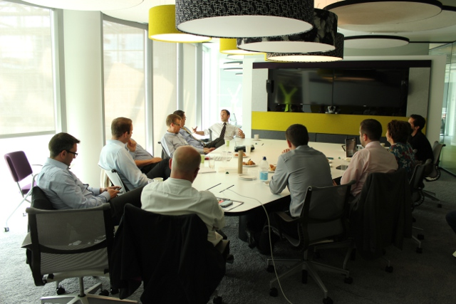

The material from the day (see <http://upintheclouds.org/assets/doc/workshop_one.pptx>) has subsequently been used in presentations by Capco and Galleons Management to articulate the typical problems and issues that emerge from running large scale residential estates.

### Erith Park photo booth deployment

We have designed, built and installed a photobooth app which is being used to help residents in Erith Park to get to know each other and to build a sense of community. It is still running today and the residents have used it to take several hundred photos.

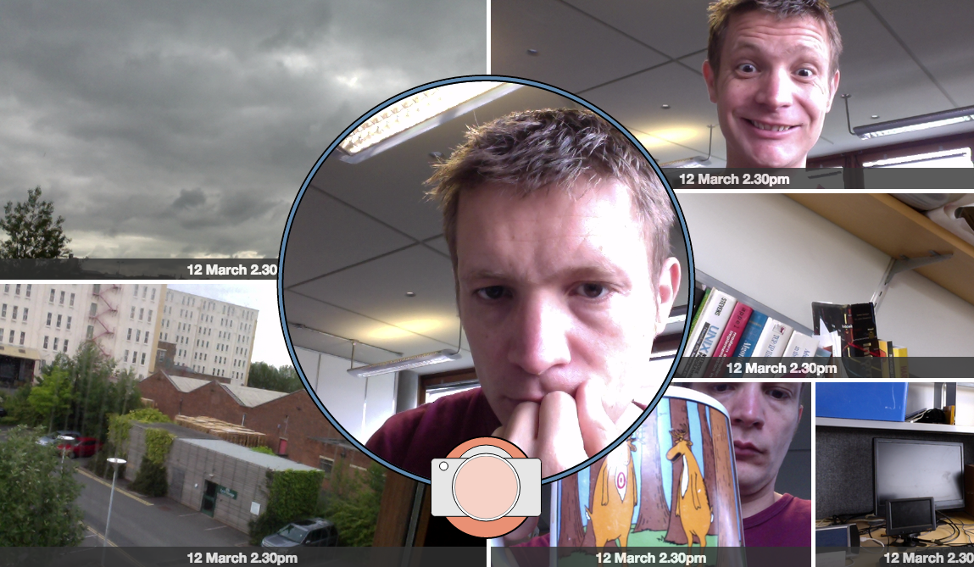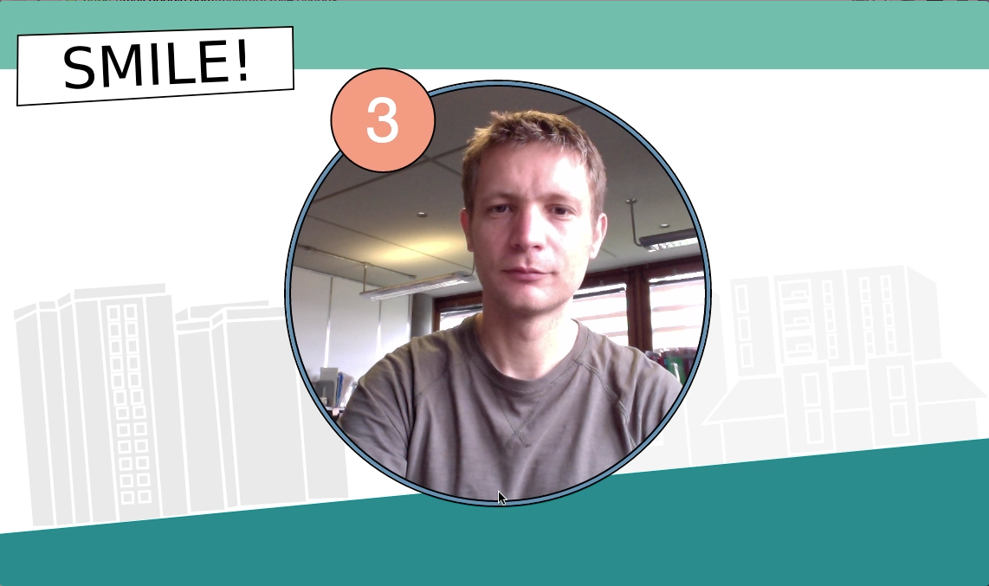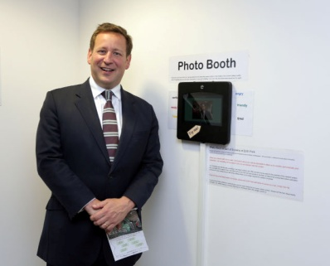

It has recently picked up interest as a novel approach to digital inclusion. The app installation was **visited by Ed Vaizey, the Minister of State for Culture, Communications and Creative Industries and was featured as a news story on gov.uk**. More importantly, our work with Orbit Housing and Erith Park lays the groundwork for future impactful in-the-wild research and we are in the process of seeking funding (Nottingham, MSR, Orbit, Horizon) to extend the work further.

# Conclusion & Implications for the future

Our work demonstrates the inherent complexity of large scale residential developments; the communities that inhabit them and the challenges of managing them effectively. Multiple themes have emerged from this work that present exciting areas for future innovation; the two that rise clearly to the top are civic engagement and governance, and community building. Such is the scope of this pilot project that we were unable to deploy as much as we would have liked; as ever, we had to work hard to gain agreement from communities to deploy; in one sense it might be suggested that we fell victim to the issues of governance and decision making that we have highlighted in D1.2.

Orbit housing are keen to install the photo booth in additional units in Erith Park and we continue to look for ways to accomplish this. So far we have submitted two (unsuccessful!) proposals for follow on funding; both proposals look to extend the Erith Park work in collaboration with Microsoft, Orbit Housing and the University of Nottingham. Our intention is to explore how social, political, and place-based characteristics of residential areas can be reflected in linked screens at sites such as a community rooms, communal areas in buildings and devices in homes. A key part of this work is an investigation of how **media might be created and shared to promote deeper participation and engagement in communal activities.** Such activities include, moving in, living harmoniously, effective governance and tapping into desires for meaningful local place-making. Our work so far leads us to believe that ***situated screens with community-level infrastructure can provide a platform for the activities of residents and groups such as Orbit***. Perhaps more importantly, we have established a good working relationship with Orbit housing and Erith Park, and have the opportunity to undertake future research in a fantastic and highly visible (given that Erith Park is a flagship estate) environment.

1. <https://communitiesintheclouds.wordpress.com/>
2. <https://communitiesintheclouds.files.wordpress.com/2014/08/17jul-workshop-transcript.pdf>
3. <http://upintheclouds.org/assets/doc/workshop_one.pptx>
4. <http://sentistrength.wlv.ac.uk/>
5. <http://upintheclouds.org/viz/barbican/>
6. http://postervote.co.uk
7. https://openlab.ncl.ac.uk
8. http://www.erithpark.co.uk/